**User Guide**

**Providing Feedback on the Federal Profile via GitHub**

June 30, 2020

**Providing Feedback**

**To View the Federal Profile:** No GitHub account is needed to view this initial catalog of IoT device cybersecurity technical capabilities and non-technical capabilities which can be found here. However, if you wish to provide feedback you can either submit feedback the traditional way to our NIST mailbox at: [IoTsecurity@nist.gov](mailto:IoTsecurity@nist.gov), or:

1. **You must establish a GitHub account to provide feedback directly through GitHub.** In order to provide feedback through the GitHub “Issues” feature, you will need to create a GitHub account.

This can be done by proceeding to <https://github.com/join>. If this is a personal account, GitHub allows you to remain pseudonymous if you would like, just make sure you select the options that suit you on the “Profile” and “Emails” pages of your “Personal Settings”. We also highly encourage you to turn on two-factor authentication in the “Security” page, also part of “Personal Settings”. **For issues submitted on behalf of an organization, we prefer a generic account named for the organization, rather than a personal account from someone within the organization.**

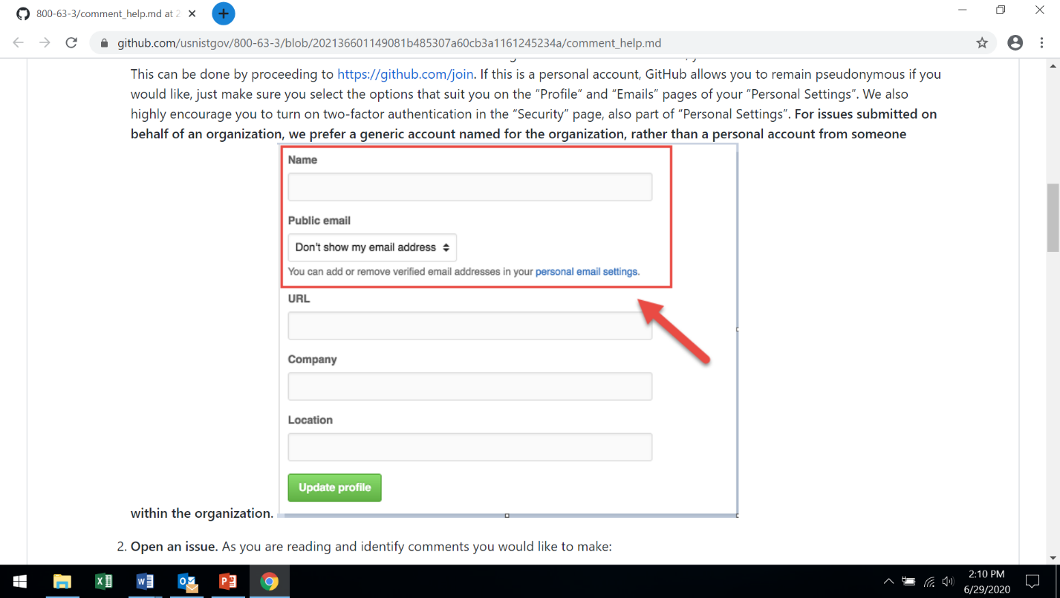

1. **Open a GitHub issue.** As you are reading and identify feedback you would like to make:
2. Click on either the "Comment" link in the sidebar navigation or the "Send Feedback" link in the footer of the page.
3. Review open and closed issues to determine if a similar issue has already been created.
4. Click on the "New Issue" button in the upper right of the screen.

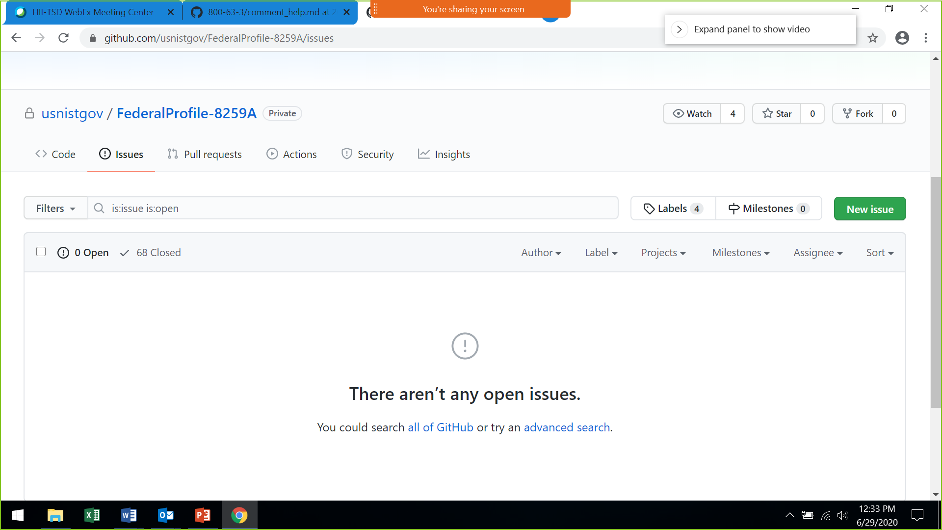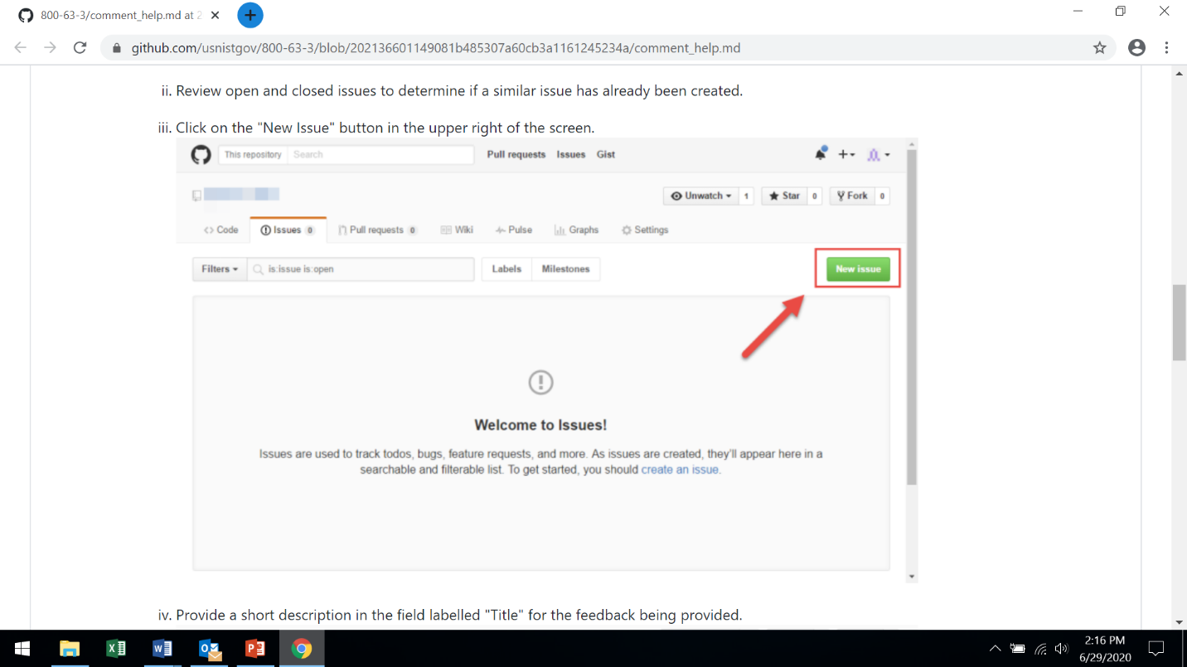

1. Provide a short description in the field labelled "Title" for the feedback being provided.

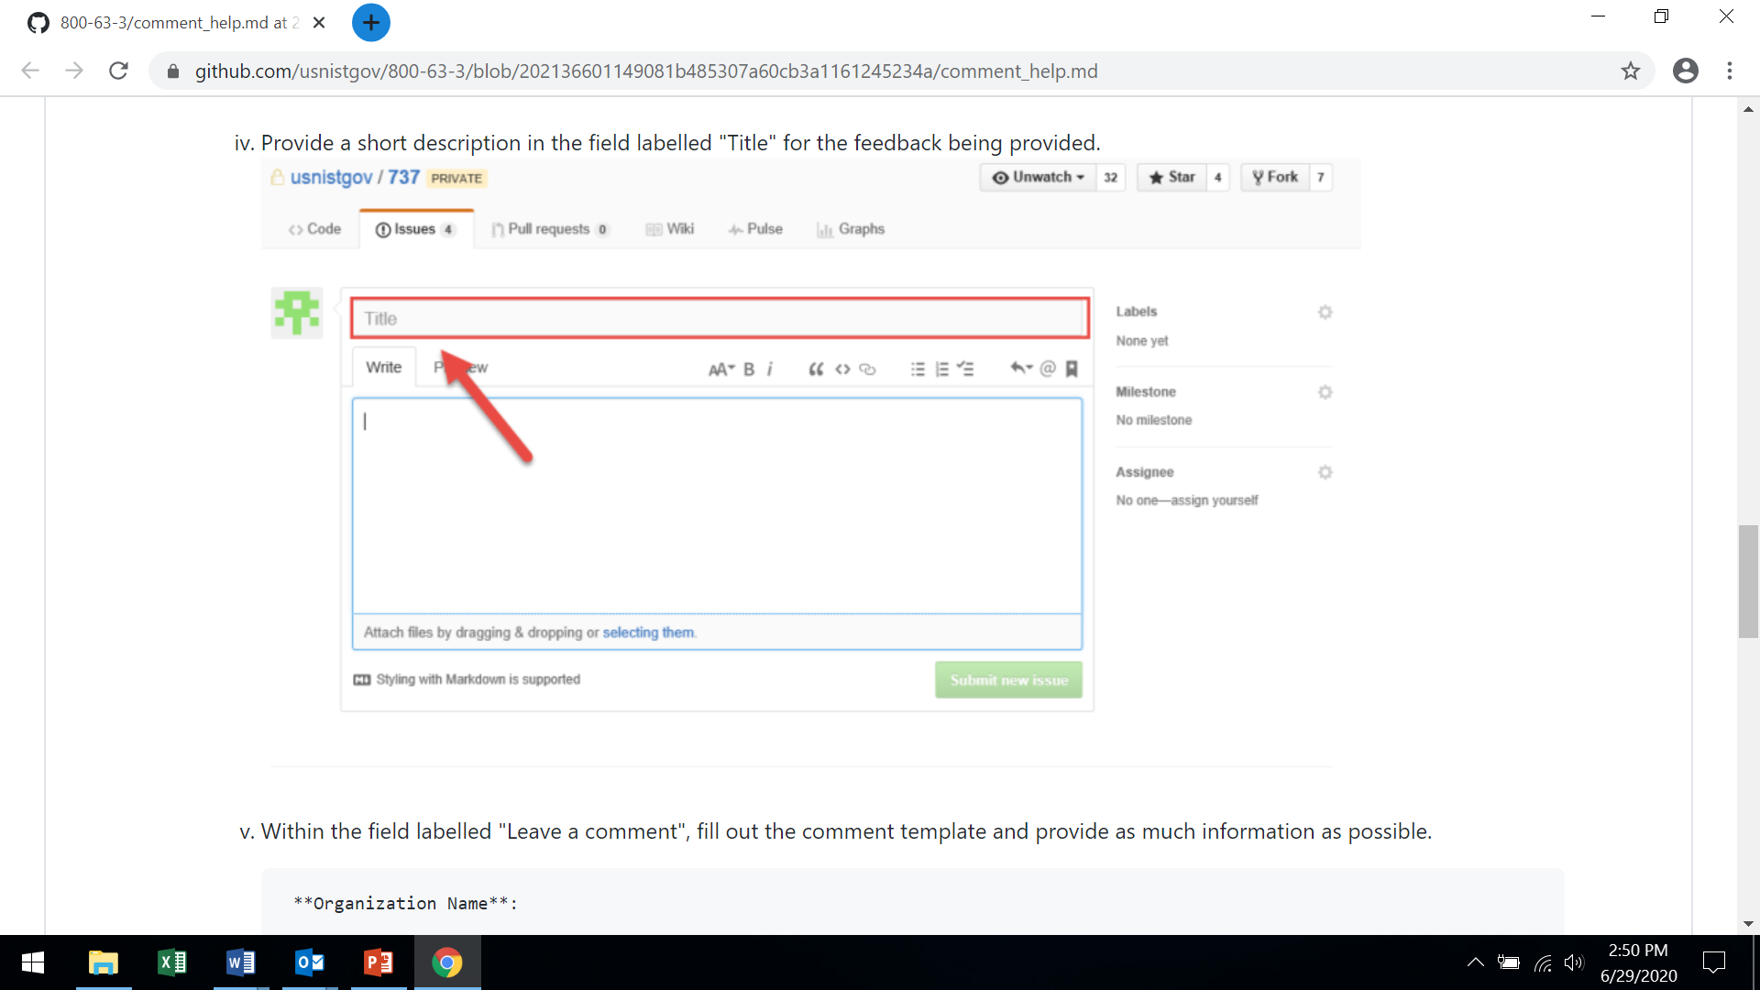

1. Within the field labelled "Leave a comment", fill out the comment with as much information as possible (a sample template is provided below).

**Organization Name**:

**Organization Type**:

**Document (Technical capabilities, Nontechnical capabilities)**:

**Reference (Include section)**:

**Feedback (Include rationale for feedback)**:

**Suggested Change**:

---

Organization: 1 = Federal, 2 = Industry, 3 = Academia, 4 = Self, 5 = Other

1. Hit “Submit New Issue” and you are done!

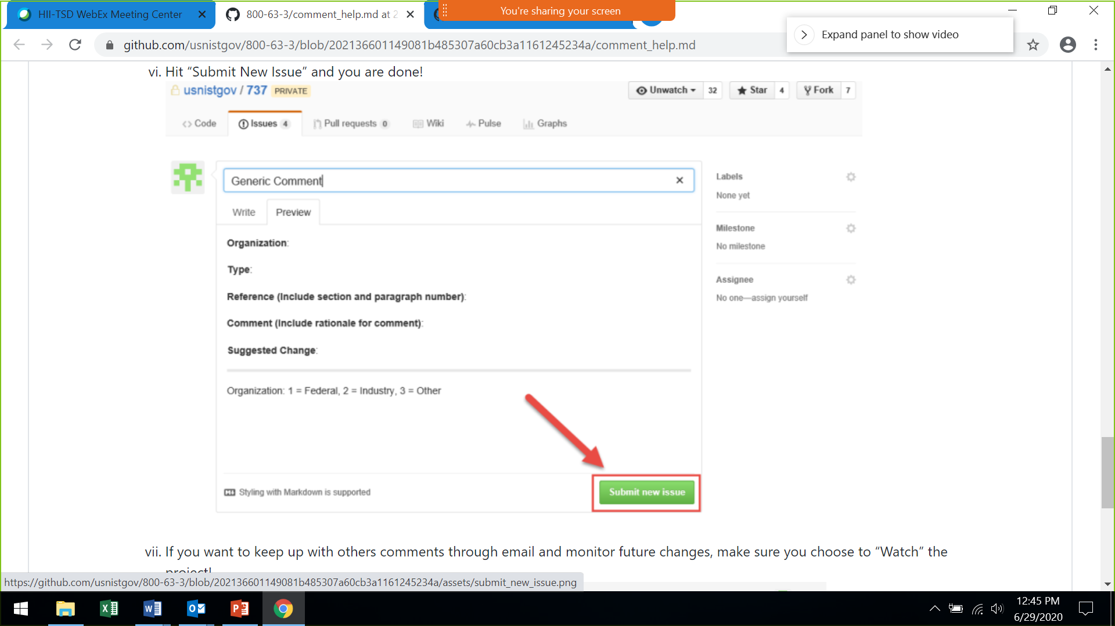

1. If you want to keep up with others feedback through email and monitor future changes, make sure you choose to “Watch” the project!

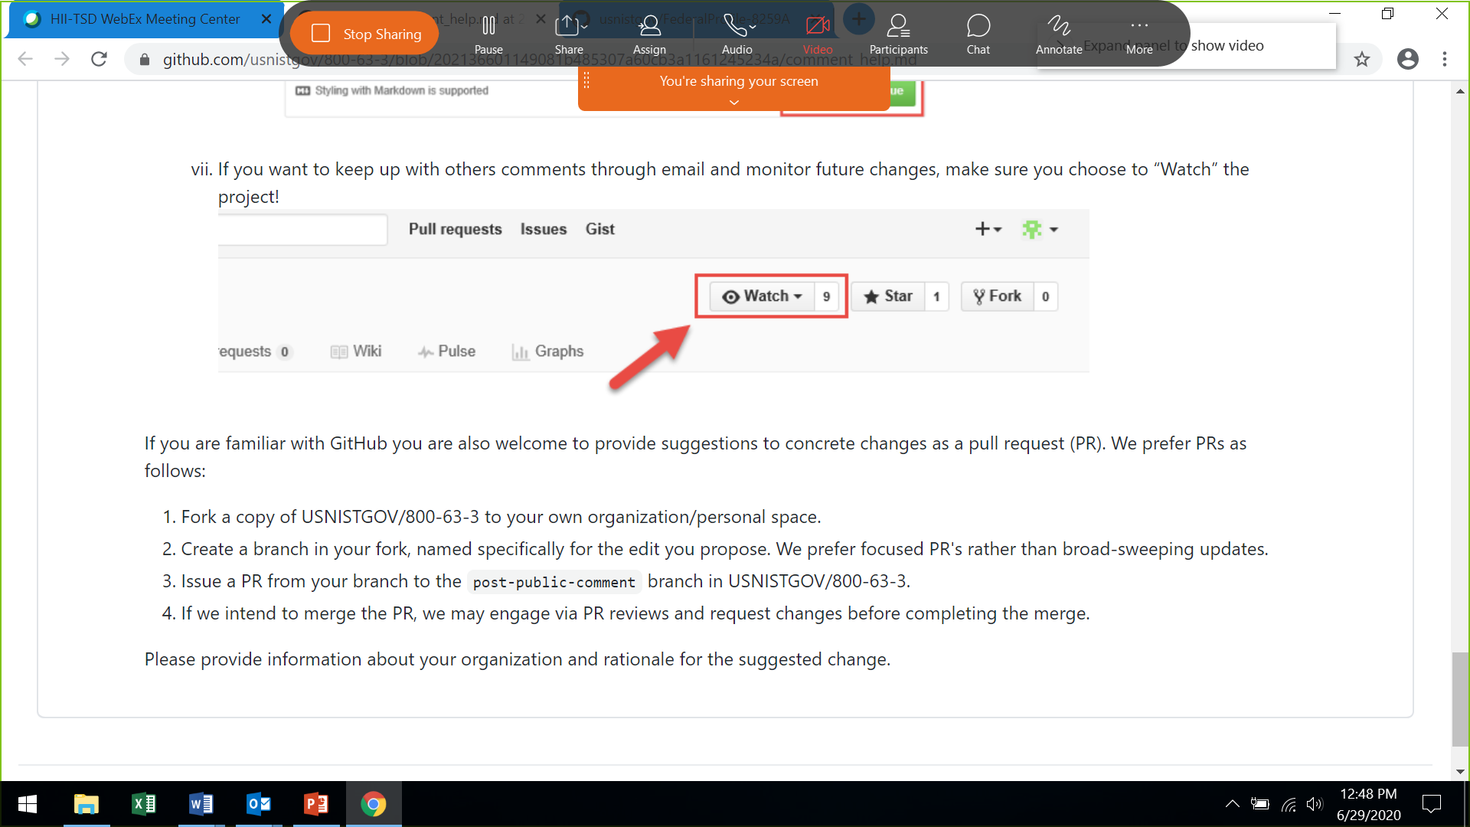

If you are familiar with GitHub, you are also welcome to provide thoughts or contributions as a pull request (PR). We prefer PRs as follows:

1. Fork a copy of USNISTGOV/FederalProfile-8259A to your own organization/personal space.
2. Create a branch in your fork, named specifically for the edit you propose. We prefer focused PR's rather than broad-sweeping updates.
3. Issue a PR from your branch to the post-public-comment branch in FederalProfile-8259A.
4. If we intend to merge the PR, we may engage via PR reviews and request changes before completing the merge.
5. Please provide information about your organization and rationale for the suggested change.